MED D - Test Claim - Calculating Quantity of Injections

Definition | An injection is a way to introduce a medicinal substance or nutrient material into the patient’s tissue.
Instructions for Running a Test Claim | How many ml does the beneficiary use each day?  What day-supply is needed?  Does the injection come in a vial or a kit?
Additional Notes | - Quantity for injections refers to the number of ml in one vial. To be as accurate as possible, determine how many ml are used each day.  - This does not apply to kits.
Common Direction (SIG) Codes | b.i.d. - 2x/day  t.i.d. - 3x/day  q.i.d. - 4x/day  ad - up to  p.r.n. - as needed  qd - every day  qh - every hour  q4h - every 4 hours  q.o.d. - every other day
What if Test Claim Rejects | Review the rejection code to determine what caused the rejection. Once the rejection code is identified, access the proper work instruction and job aids in theSource to help you resolve the issue.

Example
Cyanocobalamin
100mcg/ml

Directions: Inject 1ml daily
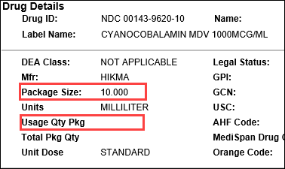 |  |  | 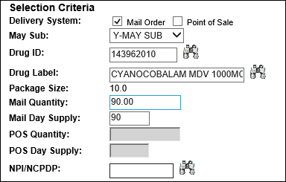
Calculation
ml Per Day | X | Days |  | = | Test Claim Quantity
1 | X | 90 |  | = | 90

Top of the Document

Related Documents
MED D - Test Claim Index
Calculating Quantities for Packaged Medication

Parent SOP: CALL-0049: Customer Care Internal and External Call Handling
Abbreviations / Definitions: Customer Care Abbreviations, Definitions, and Terms

Top of the Document

Not To Be Reproduced Or Disclosed to Others Without Prior Written Approval
ELECTRONIC DATA = OFFICIAL VERSION – PAPER COPY – INFORMATIONAL ONLY

